CNC Equipment Specifications
Mazak Machine Portfolio — Site Zero Configuration
PRELIMINARY
Aurelian Manufacturing AS | VDR 04 | February 2026 | Confidential
Source: Ravema AB Offers 25011042 / 25011043 / 25011044 | Dated 2025-11-24

1. Summary
Site Zero is configured with five Mazak CNC machines in three types, covering multi-tasking, 5-axis milling, and turning with milling capability. All machines are sourced through Ravema AB (Nordic Mazak distributor) and configured for progressive automation toward lights-out operation.

Note: This configuration is preliminary and represents the estimated scope of equipment required to serve the preferred client base. Final machine selection and option packages will be confirmed during facility planning.

Parameter | Specification
INTEGREX i-450HS×1500 | Multi-tasking turn/mill center — SmoothAi — 3 units
CV5-500 | 5-axis vertical machining center — SmoothX — 1 unit
QUICK TURN 250MSY | Turning center with milling + Y-axis + 2nd spindle — SmoothG — 1 unit

Supporting equipment includes a dedicated metrology room (Wenzel CMM, Jenoptik Opticline), material preparation (bandsaw, storage), and facility systems (Kaeser compressed air, Absolent oil mist extraction).

2. INTEGREX i-450HS × 1500
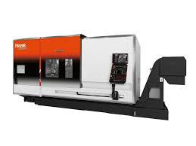
Mazak INTEGREX i-450HS — representative image (source: Ravema AB)

Multi-tasking center combining turning and milling in a single setup (DONE IN ONE®). Two spindles, B-axis milling head, 74-tool chain magazine. Primary production machine at Site Zero.
Offer: 25011043 | Qty: 3 | Control: MAZATROL SmoothAi

Key Specifications
Parameter | Specification
Axes | X, Y, Z, B, C1, C2 (index)
Max machining dia / length | Ø 670 mm / 1,500 mm
Main spindle | 12″ chuck, 37 kW, 3,300 RPM, Ø 112 mm bore
Second spindle | 10″ chuck, 26 kW, 4,000 RPM
Milling spindle | B-axis 240° travel, 12,000 RPM
Tool magazine | 74 tools — Capto C-6, chain magazine, ID chips
Coolant | 70 bar through-spindle, programmable 7 steps
Automation | Auto door, robot interface Ethernet/IP, MazaCheck
Probing | Renishaw RMP600QE + Inspection Plus
AI features | Smooth AI vibration control, energy monitoring
Chip handling | ConSep conveyor, right-side discharge
Footprint | 6,500 × 4,000 mm (machine) + 4,000 × 4,150 mm (automation)

Preliminary Order Options
Code | Description
A2271500U | Base machine — INTEGREX i-450HSx1500, SmoothAi
A227NC611 | Extra screen
A227SD140 | Foundation kit (anchor bolts and plates)
A227SI098 | C-axis spindle 2 — programmable 0.0001°
A227AT375 | 74-tool chain magazine — Capto C-6
A227MM053 | Tool for mounting/dismounting ID chips
A227AS066 | Energy monitoring
A227CP253 | Smooth Tool Management
A227CP514 | Smooth AI milling spindle — vibration minimization
A227AS080 | Cutting force monitoring
A227MO084 | Portable pulse generator
A227PL083 | Status light tower (3-colour)
A227CS527 | 70 bar coolant, programmable 7 steps
A227CS808 | Prep for 70 bar through-spindle (40 μm filtration)
A227AS321 | Automatic door (1500 mm spec)
A227CS668 | Prep for oil mist separator (Losma GX1000)
A227MB277 | Renishaw RMP600QE probe
A227MB621 | MazaCheck
A227MB624 | Renishaw Inspection Plus software
A227MB650 | Reference sphere with magnetic base
A227GL015 | Robot interface — Ethernet/IP
A227CV350 | ConSep chip conveyor, right discharge
A227CV512 | Prep for ConCep chip conveyor
A227TE810 | Multi-tool function 24 positions
A227NO056 | Mazak API
A227NO059 | MT Connect
A227NO066 | Synchronized tapping rotary tools (G84.2)
A227NO116 | EIA/ISO simultaneous 5-axis
A227NO117 | Tool tip control 5-axis (G43.4)
A227NO127 | Engraving option
A227NO128 | Cutting point control 5-axis (G43.8)
A227NO134 | Simultaneous 5-axis spindle 2
A227NO159 | Max program size 32 MB
A227NO442 | G00 Slope Constant
A227NO482 | Re-threading function
A227NO484 | Variable thread start position
A227NO507 | Coordinate rotation internal turning
A227NO531 | Turn-milling with Mazatrol
A227NO599 | Cylindrical and polar coordinates (G12.1 / G07.1)
A227YI360 | V-axis control
A227R1001 | ID chips for Capto holders (75 pcs)
A227PTekn | Production technical assistance — 5 days
A227DDP01 | DDP delivery to customer site

3. CV5-500
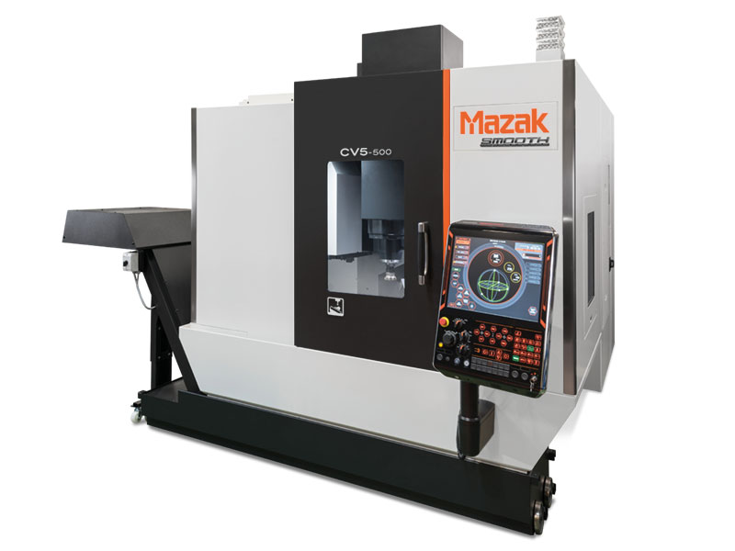
Mazak CV5-500 — representative image (source: Ravema AB)

5-axis vertical machining center with bridge construction and dual-supported trunnion table. Roller Gear Cam drive in rotary axes eliminates backlash.
Offer: 25011044 | Qty: 1 | Control: MAZATROL SmoothX

Key Specifications
Parameter | Specification
Axes | X, Y, Z, B (±110°), C (360° continuous)
Table diameter | Ø 500 mm
Spindle | 18,000 RPM, 18.5 kW, CAT-40
B/C indexing | 0.0001° — Roller Gear Cam (zero backlash)
Tool magazine | 48 tools, CAT-40
Coolant | 15 bar through-spindle and around spindle
Automation | Auto side-door, robot interface Ethernet/IP
Probing | Renishaw RMP-600 + RLP 40 + MazaCheck
Chip handling | Mayfran CleanSweep, bed and guard flushing

Preliminary Order Options
Code | Description
D34000000 | Base machine — CV5-500, SmoothX
D340CS089 | Prep for oil mist separator
D340CS213 | Through-spindle air blast (during rotation)
D340MM006 | Tool ID system (touchpanel)
D340SR395 | 18,000 RPM spindle, CAT-40
D340AT050 | 48-tool magazine, CAT-40
D340AS080 | Cutting force monitoring
D340MO060 | Portable pulse generator
D340PL082 | Status light tower (3-colour)
D340UK350 | Coolant package 4 — CleanSweep, 15 bar through + around spindle
D340PD296 | Automation package 1 — auto side-door, robot interface, table ports
D340UK358 | Measurement package 2 — RMP-600, RLP 40, MazaCheck
D340MO006 | T-slot table
D340NO056 | Mazak API
D340NO059 | MT Connect
D340NO091 | Synchronized tapping
D340NO116 | EIA/ISO simultaneous 5-axis
D340NO117 | Tool tip control 5-axis (G43.4)
D340NO123 | Radius compensation 5-axis
D340NO127 | Engraving option
D340NO157 | Max program size 8 MB
D340NO442 | G00 Slope Constant
D340PTekn | Production technical assistance — 4 days
D340DDP01 | DDP delivery to customer site

4. QUICK TURN 250MSY 1000 mm
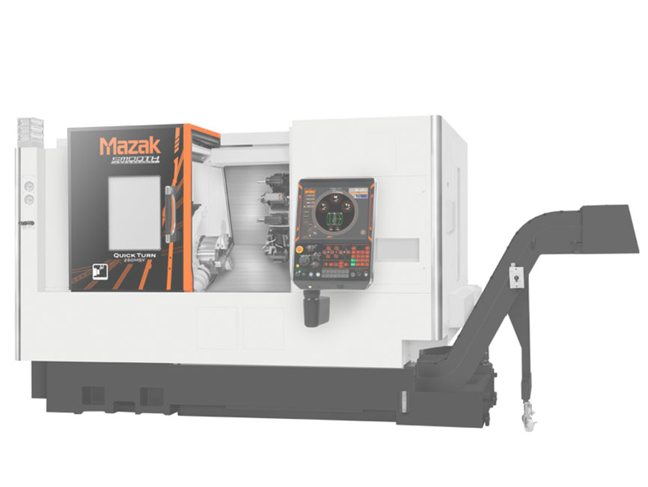
Mazak QUICK TURN 250MSY — representative image (source: Ravema AB)

Turning center with milling capability (M), second spindle (S), and Y-axis (Y). Handles complete parts in one setup. Direct-drive turret eliminates belt wear.
Offer: 25011042 | Qty: 1 | Control: MAZATROL SmoothG

Key Specifications
Parameter | Specification
Axes | X, Y, Z, C1, C2 (index)
Max swing / machining dia | 673 mm / 375 mm
Max machining length | 1,000 mm between chucks
Main spindle | 10″ chuck, 26 kW, 4,000 RPM, Ø 91 mm bore
Second spindle | 6″ chuck, 11 kW, 6,000 RPM
Turret | 12-position direct-drive, rotary tools 7.5 kW / 6,000 RPM
Y-axis travel | ±52.5 mm
Coolant | 15 bar
Chip handling | Lamell conveyor (Crowther), side discharge

Preliminary Order Options
Code | Description
B7ZK1000U | Base machine — QT 250MSY 1000 mm, SmoothG
B7ZKCS176 | Through-turret air blast
B7ZKPD106 | Productivity package Crowther — bar feeder interface, auto part catcher, 15 bar coolant, chip conveyor
B7ZKSI095 | C-axis spindle 2 — programmable 0.0001°
B7ZKAS080 | Cutting force monitoring
B7ZKPL083 | Status light tower (3-colour)
B7ZKCS628 | Prep for oil mist separator G500
B7ZKNO059 | MT Connect
B7ZKNO127 | Engraving option
B7ZKNO157 | Max program size 8 MB
B7ZKNO482 | Re-threading function
B7ZKNO602 | Cylindrical interpolation (G07.1)
B7ZKPTekn | Production technical assistance — 4 days
B7ZKDDP01 | DDP delivery to customer site

5. Support Equipment

5.1 Metrology Room
Parameter | Specification
CMM | Wenzel LH 87 Revo — parts up to Ø 350 mm, 1,500 mm length
Optical | Jenoptik Opticline — shaft measurement and contour analysis
Handheld | Micrometers, bore gauges, surface roughness testers, calipers

5.2 Material Preparation
Parameter | Specification
Automatic bandsaw | Max Ø 360 mm, programmable cut lengths
Manual bandsaw | Backup / secondary cuts
Storage | Raw material shelving with traceability

5.3 Facility Systems
Parameter | Specification
Compressed air | Kaeser compressor + Secotec refrigeration dryer
Oil mist extraction | Absolent system, ducted for 4 machines
Material handling | Forklift, 3.5 t capacity

6. Automation Readiness
All machines are specified with automation-ready options supporting progressive rollout from manual operation to lights-out production.

Parameter | Specification
Feature | INTEGREX (3) / CV5-500 (1) / QT 250MSY (1)
Robot interface | Ethernet/IP on all INTEGREX + CV5-500
Auto door | INTEGREX (auto door) + CV5-500 (auto side-door)
In-process probing | Renishaw RMP600QE (IG) / RMP-600 (CV5)
Geometry check | MazaCheck on INTEGREX + CV5-500
Tool management | Smooth Tool Management + ID chips (INTEGREX)
AI optimisation | Smooth AI vibration control (INTEGREX)
Connectivity | MT Connect + Mazak API on all machines
Bar feeding | Crowther bar magazine interface (QT 250MSY)

Control platforms: SmoothAi (INTEGREX), SmoothX (CV5-500), SmoothG (QT). All share Mazatrol conversational programming and iCONNECT cloud monitoring.

7. Commercial Terms
Identical terms apply across all three Ravema offers.

Parameter | Specification
Delivery | FCA Göteborg, upgraded to DDP customer site (Hølen)
Delivery time | To be agreed (subject to global supply chain)
Payment | 30% at order / 60% at delivery / 10% after approval — all 30 days net
Currency | Based on 1 EUR = 11.80 SEK, adjusted at payment date
Training | Mazatrol course at Ravema Värnamo (2 persons/machine) + on-site 8 hrs
Tech assistance | 4–5 days per machine, included
Warranty | 12 months regardless of operating hours
Warranty conditions | Preventive maintenance every 3,000 hrs, documented
General terms | NL 01 (Swedish standard delivery terms)
Non-proliferation | Relocation detector — locks if moved without Mazak authorisation

8. Reference Documents
Supplier Offers
▸ 25011042 — Quick Turn 250MSY 1000 mm
▸ 25011043 — INTEGREX i-450HSx1500
▸ 25011044 — CV5-500

Machine Specs & Layouts
▸ Maskinspec_Quick_Turn_250MSY_1000_mm_2.pdf
▸ Maskinspec_Integrex_i450HSx1500_3.pdf
▸ Maskinspec_CV5500_8.pdf
▸ Layout and foundation drawings (QT, IG, CV5)

Support Equipment
▸ Secotec dryer, Kaeser compressor & air receiver prospectuses
▸ Investeringer_Maskiner_og_Utstyr.xlsx — equipment register

Related VDR Documents
▸ 04_CNC_Resale_Value_Analysis.pdf
▸ 04_Automation_Feasibility_Study.pdf

